**Lab #09**

**Effect of pre-heater on Bench-top Cooling Tower Trainer**

* **Introduction:**

A cooling tower is a specialized heat exchanger in which air and water are brought into direct contact with each other in order to reduce the water's temperature. As this occurs, a small volume of water is evaporated, reducing the temperature of the water being circulated through the tower.

* **Explanation & Principle:**

Cooling tower rejects waste heat to the atmosphere through the cooling of water to a lower temperature.

There are different type of cooling tower present. Lets understand the simplest one with the figure:

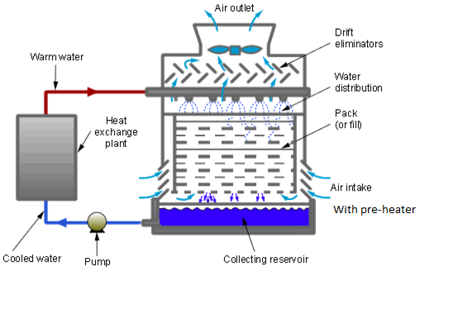

The water is distributed through a pipe system to spray nozzles which disperse water from the top. Air has been supplied to cooling water from the bottom and when it comes into the contact with water, water exchanges heat with air and cools down. The hot air exits in the atmosphere and cool water is collected into the sink and can be used again for whatever the purpose you are using.

**Parts:**

Cooling Tower consists of the following parts:

* The Stimulated Condensor
* The Water Pump
* The Water Filter
* The Flow metre
* Water Distributer
* Section Column
* Fill
* Fan
* Air distribution chamber
* Anemometer
* Pre-heater
* **Labled Diagram:**

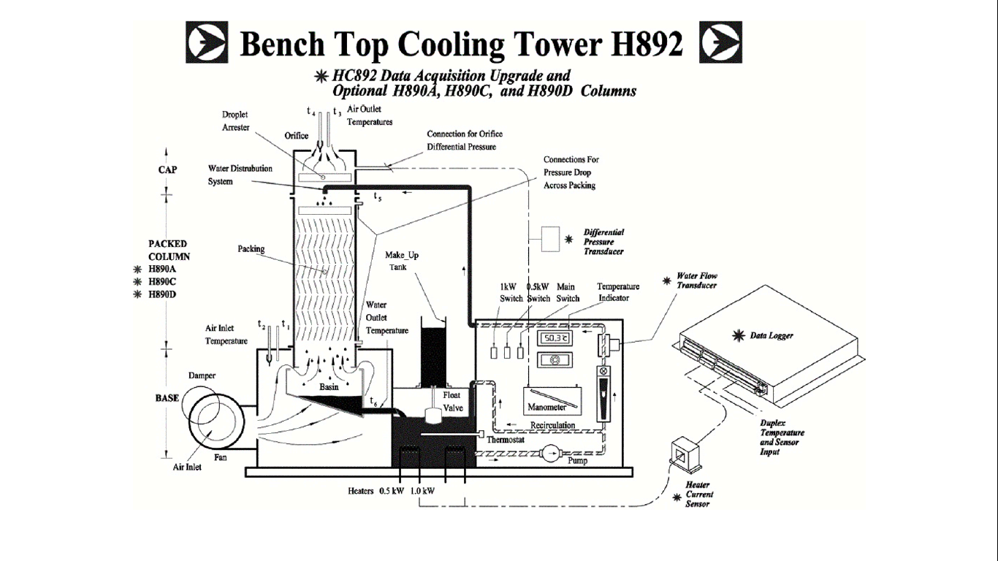

* **Effectiveness of the tower:**
* T1=Dry bulb temperature of air at inlet
* T2= Wet bulb temperature of air at inlet
* T3= Dry bulb temperature of air at outlet
* T4= Wet bulb temperature of air at outlet
* T5=Water inlet temperature at top
* T6= Water outlet temperature at outlet
* T7=Temperature of makeup tank
* **Calculations:**

Water flow rate= 6 l/min

Speed of air= 9.5 m/s

Pre-heater=0.5 KW

|  |  |
| --- | --- |
| Temperature | Value |
| T1 | 18 |
| T2 | 18 |
| T3 | 19 |
| T4 | 21 |
| T5 | 22 |
| T6 | 19 |
| T7 | 13 |

Range = T5 -T6=22-19=030C

Approach=T6 - T2=19-18=010C

Effectiveness = $\frac{Range}{Range+approach}×100$ $=\frac{03}{03+01}×100=75\%$

* **Uses & Applications:**

Cooling towers are primarily used for heating, ventilation, and air conditioning (HVAC) and industrial purposes. More than 1,500 industrial facilities use large quantities of water to cool their plants 2. HVAC systems are used typically in large office buildings, schools, and hospitals. Common applications include cooling the circulating water used in oil refineries, petrochemical and other chemical plants, thermal power stations, nuclear power stations and HVAC systems for cooling buildings.